FULL STACK DEVELOPMENT
Lab Exercise-2: Develop a responsive webpage layout using Tailwind CSS

1. Source Code (index.html)

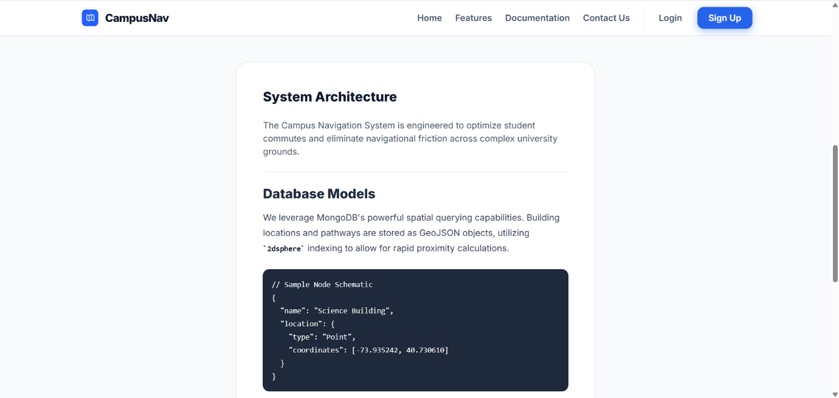
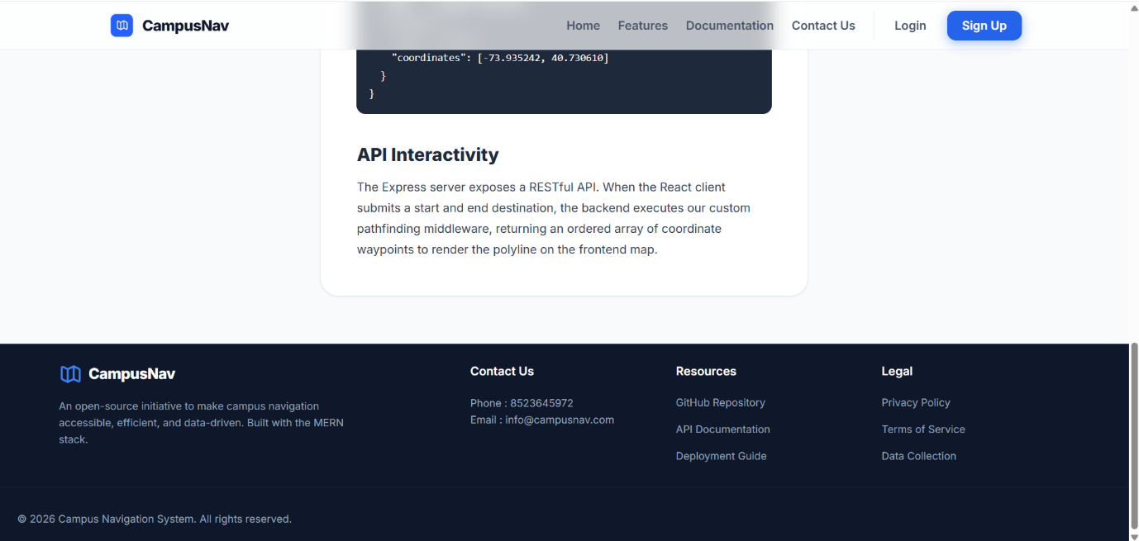
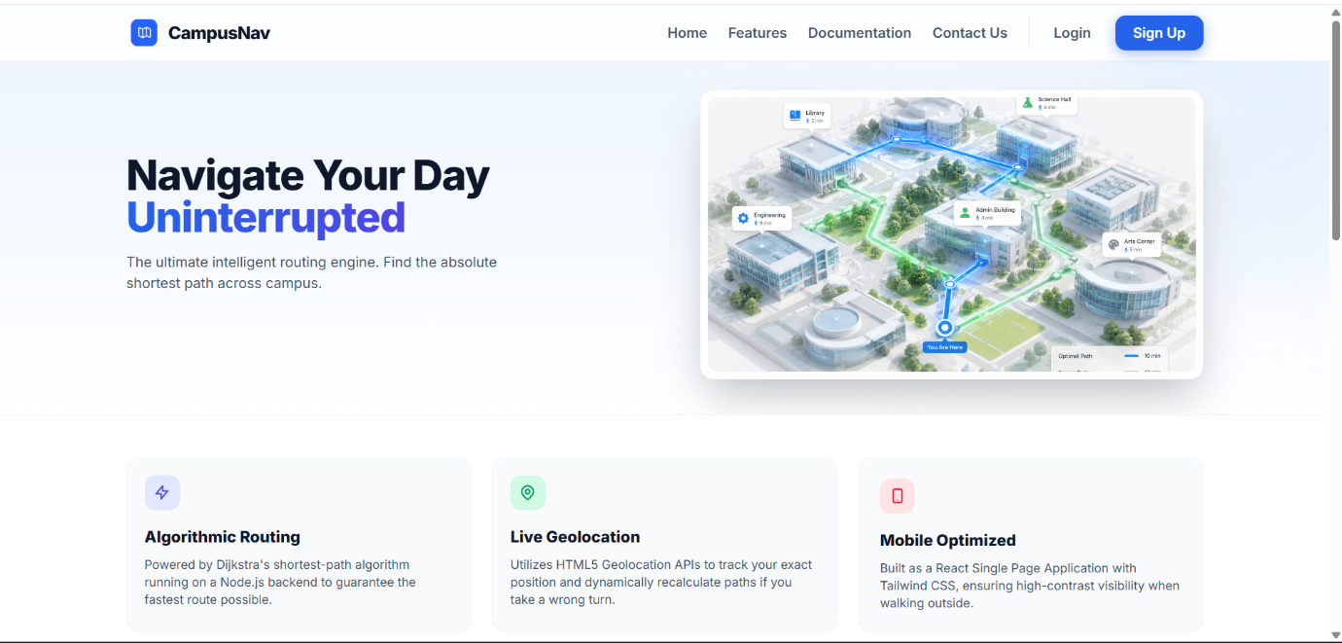
2. Screenshots (Landing page)
3. GitHub Repository Link (GitHub Repository URL)
GitHub Link: https://github.com/GTAPRO7/FSD_LAB
Live Deployment: https://gtapro7.github.io/FSD_LAB/
4. AI Usage Declaration (AI Tools and Purpose of usage)
AI Used: Google Gemini
Usage:
In this process of developing the campus navigation system, several generative AI tools have been leveraged in order to facilitate the research and prototype creation. In particular, the Google Gemini tool has been used as a research assistant to identify and analyse the most relevant HTML5 APIs (Geolocation, Video, History etc). In addition, AI video generation feature of Gemini was used to generate a sample video for the demo of video API. All the recommendations of the AI were verified and incorporated according to project needs.

